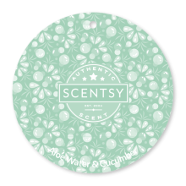  Aloe Water & Cucumber  ALOE WATER, CUCUMBER PEEL, PALM FROND and PINEAPPLE NECTAR are oh-so-mellow. | 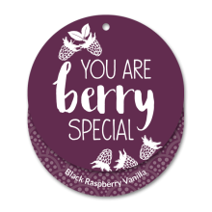  Black Raspberry Vanilla  Delicious, sun-sweetened dark berries warmed with vanilla. | 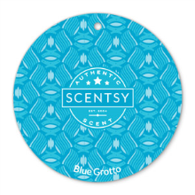  Blue Grotto  Run away with fresh tropical notes, sweet citrus and lush botanicals. | 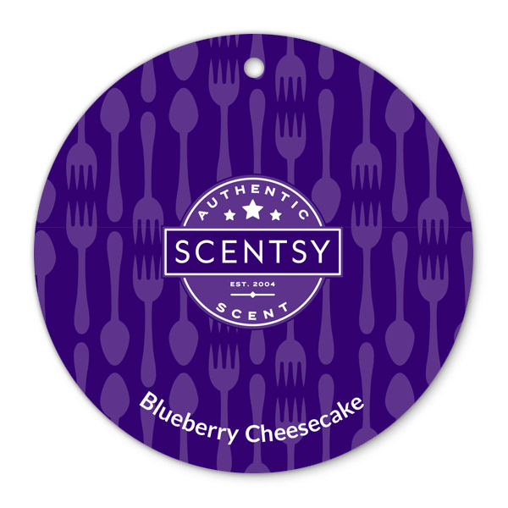  Blueberry Cheesecake  Thick, rich NY cheesecake with a light graham cracker crust and delicious blueberries.
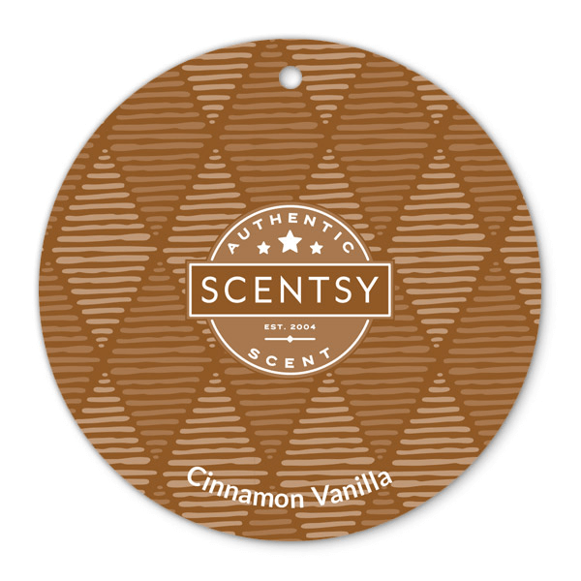  Cinnamon Vanilla  Inviting blend of vanilla beans, cinnamon, coconut and cassia. | 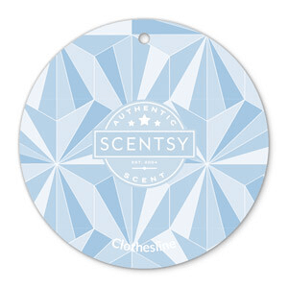  Clothesline  Crisp greens, orange flower, creamy violet and even a hint of white wicker basket will let you savor the scent of just-washed laundry — dried naturally in the fresh air — anytime you please. | 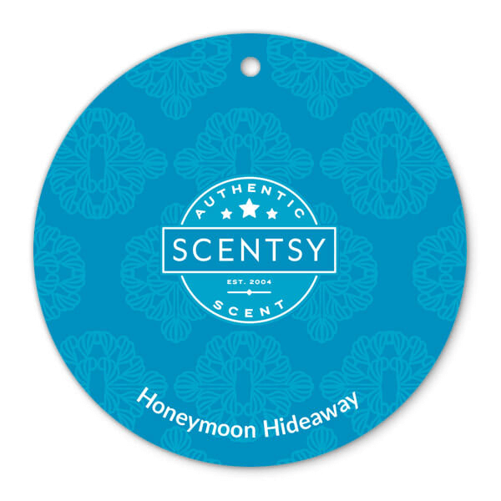  Honeymoon Hideaway  Escape to a secluded retreat of dew-kissed lily and tart-sweet kiwi, shaded by lush coconut palm. | 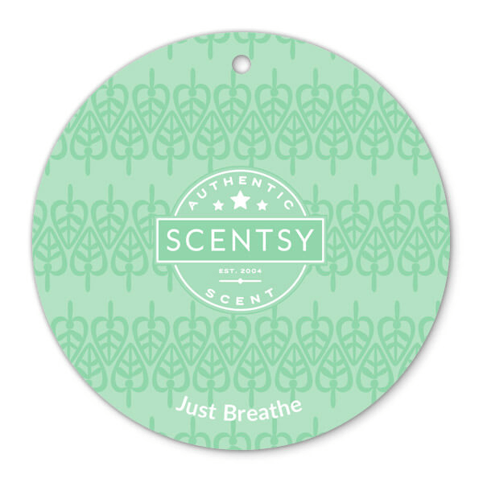  Just Breathe  Breathe deeply as soothing eucalyptus, zesty lemon, and a medley of mints comfort and rejuvenate.
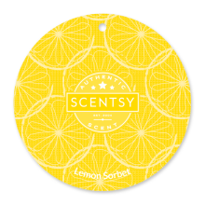  Lemon Sorbet  Fresh-cut lemon and grapefruit zest sweetened by sugarcane. | 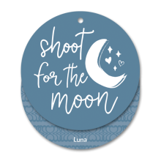  Luna  White florals — jasmine, sweet pea, and freesia — juicy berries, and sandalwood shimmer like moonlight. | 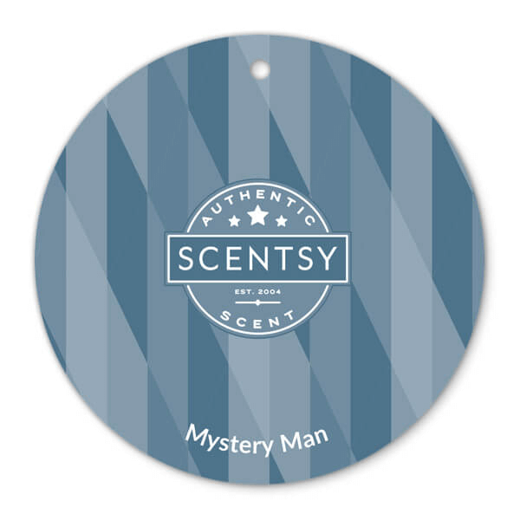  Mystery Man  Warm white cedar, green verbena and citrusy bergamot in a perfectly spiced, sensual fragrance. | 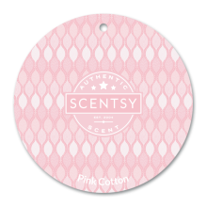  Pink Cotton  Find your fantasy on a cloud of CLEAN COTTON swirled with fruity PINK BERRIES and VANILLA SUGAR.
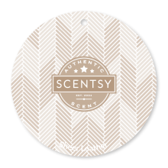  Sheer Leather  Slip into something more sensual, like BERGAMOT, a subtle hint of LEATHER and SANDALWOOD. | 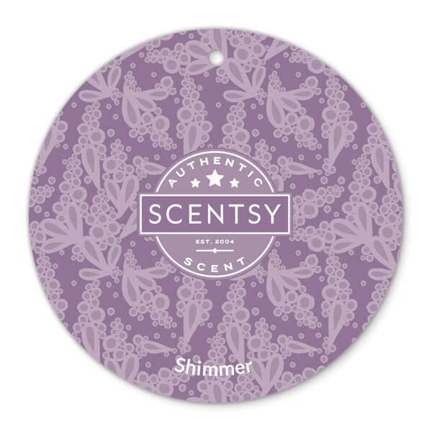  Shimmer  Get your girly-girl on! Sweet cherries, velvety apricots, and sensual white musk crowned with a tiara of shimmering spun sugar. | 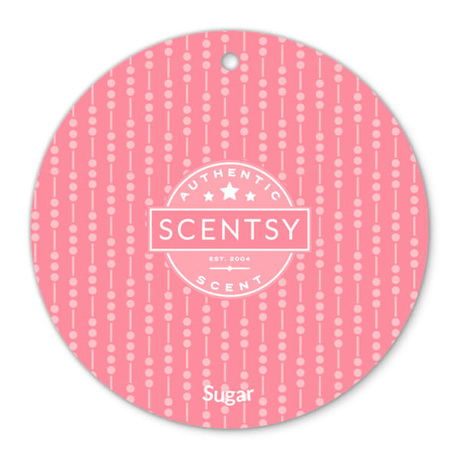  Sugar  Fruity blend of lemon drops and cotton candy. | 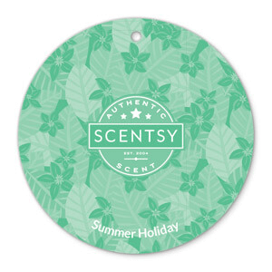  Summer Holiday  Steal away to a sunny isle bursting with lush plumeria, tiger lily and sweet orange softened by vanilla and radiant amber.
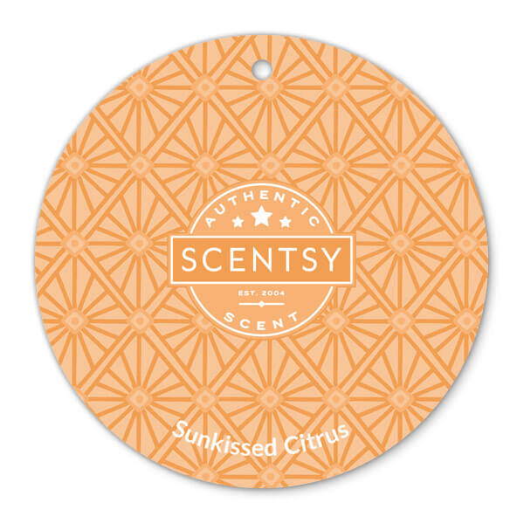  Sun kissed Citrus  Lively blend of oranges, lemons, limes, and grapefruit. | 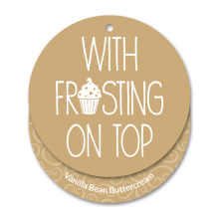  Vanilla Bean Buttercream  Decadent buttercream frosting made with the freshest butter whipped with cane sugar and vanilla extract. So creamy and sweet you will have to lick the spoon! | 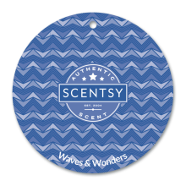  Waves & Wonders  Dewy BEACH GRASS and COASTAL CYPRESS will have you feeling the AMBER SAND between your toes. | 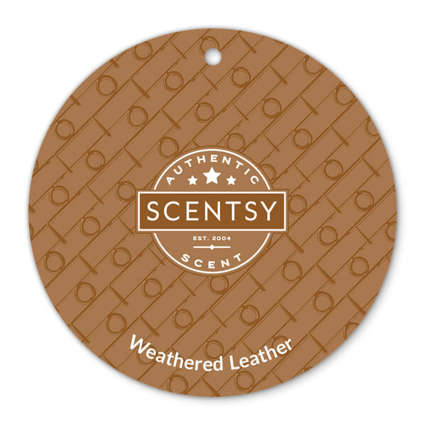  Weathered Leather  Step into an old-fashioned saddle shop brimming with dark suede and tooled leather over a backdrop of oak.

CFA Scent Circle
Fundraiser!

Scent circles are sold in sets of 6 for $20, which includes any tax and shipping.

Ways to use Scent Circles
Vehicles
Closets
Lockers
Trash cans
Gym Bag
As a gift
& more

Choose 6 different scents or all the same scent.
YOUR CHOICE!

Thank you for supporting your CFA Cheerleaders!.

FUNDRAISER!
We’re having a Scent Circle

